

TLE Observation & Evaluation Handbook for Evaluators using the
Tulsa Model
2012-2013
A reference and process guide for the Teacher and Leader Effectiveness (TLE) evaluation, support system and processes for teachers—developed collaboratively by Oklahoma teachers and administrators within the Tulsa Public Schools.

© 2012, Tulsa Public Schools
TLE Observation and Evaluation
Handbook for Tulsa Model Evaluators
2012-2013

Table of Contents
Page
Introduction 2
Purpose of the Handbook 2
Section 1: The Background 3
Section 2: Introduction to Rubrics and Performance Rankings 5
Section 3: Overview of the System’s Weighted Scoring 7
Section 4: The TLE Observation and Evaluation Process and Timeline 8
Master Calendar of Evaluation Deadlines 11
Section 5: The Observation and Observation Conference 12
Section 6: The Evaluation and Evaluation Conference 15
Section 7: The Personal Development Plan 20
Section 8: Intensive Mentoring 23
Section 9: Tulsa Model Key Personnel 24

Introduction

In 2010, Tulsa Public Schools embarked on a new teacher and leader effectiveness initiative in support of its mission of "Excellence and High Expectations with a Commitment to All." At the heart of this mission is our core goal of raising student achievement. We recognize that in a high-performing school system, there must be an emphasis on continuous improvement and shared accountability for student achievement. Instructional practices grow and student achievement levels rise in an organization that values performance feedback, analysis and refinement.
Student achievement requires an effective teacher and leader at every site. Our TLE Observation and Evaluation System is designed to help measure and support teacher effectiveness. It is based upon current research and best practices—with authorship and input from Oklahoma's teachers and administrators.
Purpose of the Handbook | The goal of this document is to guide evaluators’ use of the TLE Observation and Evaluation System—providing clear expectations on what must be done and when. The handbook, the TLE teacher rubric, observation and evaluation forms, and the PDP form comprise the primary documents of the TLE observation and evaluation process.
We have continued to evaluate and improve the system since it was piloted in the spring of 2010. The value of the system’s framework and processes depend upon the lessons we learn from teachers and evaluators implementing the processes as well as rigorous, independent research. As such, we welcome your frank and thoughtful input about its effectiveness. We read and listen gratefully to your comments and are actively seeking opportunities to test the usefulness and efficacy of the system’s observation and evaluation practices. Together we can optimize the effectiveness of the Tulsa Model’s TLE Observation and Evaluation System and its ability to positively impact student achievement across Oklahoma.
1. The Background

1.1  A Research-Based, Collaboratively Designed Process | In consultation with national experts in teacher and leader effectiveness, Oklahoma teachers and administrators have developed this research-based, independently validated evaluation process. A critical accomplishment of their effort is the teacher rubric that provides detailed descriptions of different proficiency levels and identifies the knowledge, skills and practices correlated with growth in student achievement. The rubric was designed in collaboration with the Tulsa Classroom Teachers' Association (TCTA) using current research and knowledge of the best practices underpinning professional competencies.
1.2  Feedback-Driven Improvements | As a result of survey and stakeholder forum feedback from teachers and leaders, the observation and evaluation forms of the TLE system were substantially simplified and improved in the summer of 2011 and the spring of 2012. In late January 2012, the District received the results of the validation study conducted by Empirical Education, one of the research organizations implementing the MET Validation Engine Pilot in cooperation with the Bill and Melinda Gates Foundation. The District also received validation results from the University of Wisconsin. The findings of the MET Validation Engine study and the validation study from the University of Wisconsin were positive and confirmed, once again, that the Tulsa model measures what matters—it captures practices that are empirically associated with gains in student achievement. Specifically, the studies revealed that every indicator included within the Tulsa model that a principal uses when observing a classroom performance is positively correlated with growth in student achievement as measured by state assessments. The results of that validation study as well as a similar analysis conducted by the University of Wisconsin (with similar results) are detailed in the research brief submitted to the State Department of Education on March 7, 2012.  Because the District is committed to continuous improvement and a successful rollout of the Tulsa model state-wide, it incorporated a minor update to its model to reflect the new research findings. Namely, while each of the indicators within the rubric is positively correlated with student growth, Indicator 6, the indicator pertaining to the physical organization of the classroom, is only minimally associated with student achievement growth. Indicator 19, on the other hand (regarding a teacher's interactions with students, colleagues, families and stakeholders), addressed multiple practices within a single measure, each of which has solid correlations with growth in student achievement. In light of these findings, the District (with input from principals and teacher representatives) has decided to eliminate the language which had been in Indicator 6 and replace it with one of the multiple practices measured within Indicator 19 —in particular, the teacher's interactions with students.
As a result of replacing Indicator 6 with this language taken from Indicator 19, Indicator 6 will measure a teacher practice with stronger links to student growth, and Indicator 19 will be more focused, relating exclusively to a teacher's interactions with individuals other than students. The District also clarified language and made formatting improvements to the model for the sake of clarity and simplification.

As noted in the introduction, we will continue to solicit and respond to user input in order to continuously improve the system for purposes of improving student achievement.

1.3  Training | The TLE system processes require a series of on-going, informative and responsive training opportunities for learning, improvement and growth. The primary vehicles for this development are facilitated learning circles as well as professional learning community work. The learning circles will be tailored to the needs of the participants and will emphasize processes, effective practices and technology tools, allowing for re-training where needs arise. An intensive focus of training is to support and ensure evaluators’ inter-rater reliability and accuracy.

2. Introduction to Rubrics and Performance Rankings

2.1  Overview of Domains, Dimensions and Indicators | The TLE Observation and Evaluation System is an evidence-based process of teacher evaluation, feedback and support anchored in specific domains, dimensions and indicators reflecting national best practices and current research regarding effective instruction. The domains, dimensions and indicators within a rubric categorize and explicitly define effective teaching/performance along a spectrum of professional proficiency. The rubric creates a common language to guide evaluators’ understanding of expectations and the various levels of performance.
2.2  How the Rubric's Domains, Dimensions and Indicators Enhance Assessments and Determine the Performance Ranking | Each domain has one or more dimensions and indicators. When performing an observation or evaluation, an evaluator must judge the teacher’s performance as to each indicator. The evaluator bases his or her score for an indicator according to the rubric. The rubric contains a set of detailed narratives—scoring guidelines developed collaboratively by the district's administrators and teachers based upon professional practices linked to student learning. By evaluating the teacher's performance using the rubric's narratives, the evaluator:  - Creates a common framework and language for evaluation.  - Provides teachers with clear expectations about what is being assessed, as well as standards that should be met.  - Send messages about what is most meaningful.  - Increases the consistency and objectivity of evaluating professional performances.  - Provides teachers with information about where they are in relation to where they need to be for success.  - Identifies what is most important to focus on instruction.  - Gives teachers guidance in evaluating and improving their work.  The evaluator’s assessment is a reflection of the teacher's performance during formal observations as well as his or her overall performance. The evaluation software, whether Excel-based or web-based, calculates the average score for each domain according to the scores entered for each indicator within the domain. The overall evaluation score—the composite average—is determined by calculating a weighted average of the evaluation's domain scores.

2.3  Rankings of Performance | The rubric's descriptions as to each indicator are organized along a five-point scale with numeric rankings of 1 - 5. The rankings of N/A and N/O are used for not applicable and not observed behavior (evidence) respectively. The numeric scores represent the following rankings:  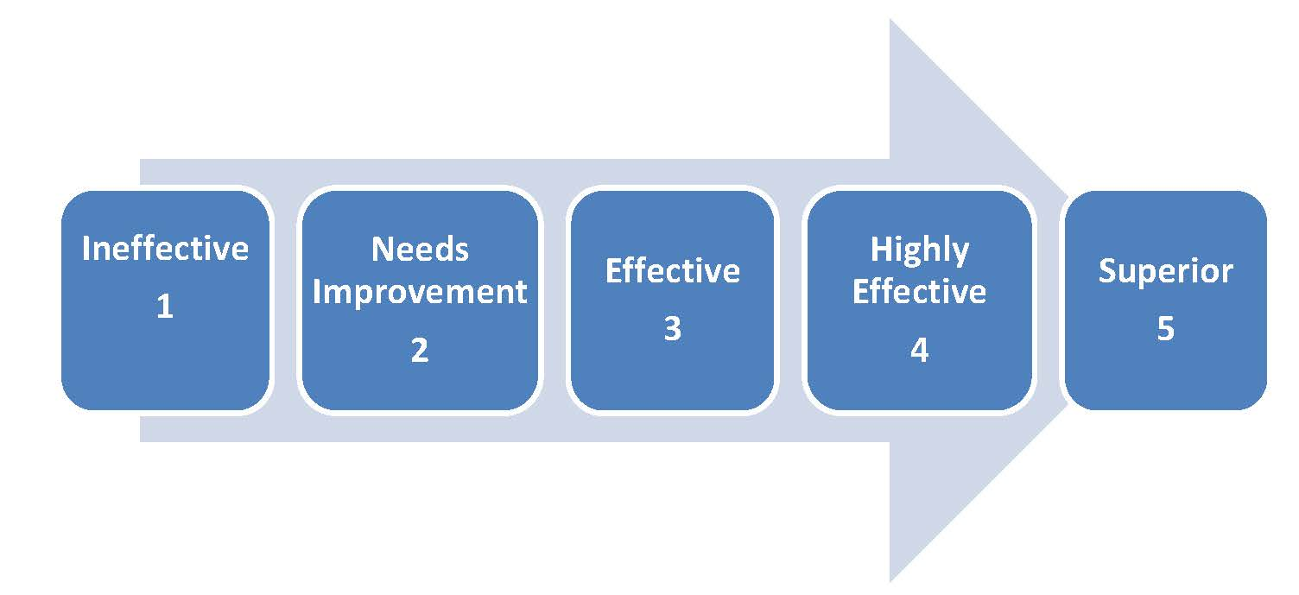

3. Overview of the System's Weighted Scoring

3.1  Relative Weights of Domains | Domains vary in importance, especially with regard to how much they impact student achievement. For purposes of establishing the overall effectiveness of a teacher's performance, and hence the overall evaluation score, the TLE Observation and Evaluation System weights the rubric's domains according to their relative importance.
Domains...
Their weights and their number of Indicators

 | Classroom Management  (% weight / # of indicators) |  |  | Instructional  Effectiveness  (% weight / # of indicators) |  | Professional Growth  (% weight / # of indicators) |  | Interpersonal  Skills  (% weight / # of indicators) |  | Leadership  (% weight / # of indicators)
 | 30% / 6 |  |  | 50% / 10 |  | 10% / 2 |  | 5% / 1 |  | 5% /1

4. The TLE Observation and Evaluation Process and Timeline

4.1  The Evaluation Pyramid | The TLE evaluation process is comprised of observations, evaluations, conferencing and opportunities for feedback and support. Every evaluation must be supported by (built upon) at least two observations in addition to the evaluator’s overall assessment of the teacher’s performance.  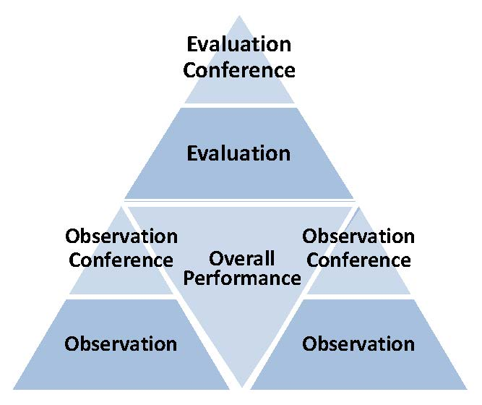
4.2  Who Performs the Observations and Evaluation | Only certified administrators who have completed the evaluation certification training may conduct observations and evaluations.  The evaluator who begins the observation process should see the assessment of the teacher’s proficiency to completion through the issuance of an evaluation, including PDPs if applicable. Buildings with 2 evaluators shall not share an individual teacher’s TLE process by dividing up the observations nor shall 1 evaluator do the observations with the other completing the evaluation process.
4.3  Career Teachers v. Probationary Teachers | Career teachers must be evaluated at least once a year.   Probationary teachers must be evaluated at least twice a year. 

4.4  Observations | Observations are an evaluator's intentional study and analysis of the teacher's performance (e.g., the teacher's classroom instruction). The observation rating reflects the evaluator’s assessment of the teacher’s classroom performance and other factors that quantify the impact of the educator—up to, and including, the date of the classroom observation. The evaluator's assessment is guided by the detailed descriptions of the teacher's rubric. The evaluator's assessments of the teacher's performance during the observation must be recorded in the observation form, described in more detail in Section 5. Each observation must be followed by an observation conference held no more than five (5) instructional days from the date of the observation. Observations shall not be conducted on the day immediately following any extended break in the instructional calendar year (whether scheduled or unexpected).
4.5  Evaluations | Evaluations reflect the evaluator's overall assessment of the teacher based upon the underlying observation forms, the observation conferences and the evaluator's general appraisal over the course of the year of the teacher's proficiency in the relevant indicators.  The evaluator records the teacher's score for each indicator on the evaluation form, which is described in more detail in Section 6. The evaluator must provide the teacher with a copy of the evaluation form at an evaluation conference.
4.6  Observation Deadlines for 2012-2013 | Because probationary teachers must receive 2 evaluations and career teachers 1 evaluation during a school year, each district must develop a deadline schedule for observations that addresses the specific needs of the schools and the district. Time management is a key to the successful implementation of the observation / evaluation processes. It is recommended that early August of each year be designated as the time for the creation of observation deadlines.
4.7  Evaluation Deadlines for 2012-2013 | For probationary teachers:  - 1st evaluation: November 15, 2012  - 2nd evaluation: Feb. 10, 2013  For Career Teachers:  - April 30, 2013 - This is a recommended deadline only. Districts should follow their written policies of evaluation and bargaining agreements, as applicable.  - unless the first observation resulted in a personal development plan (PDP), in which case the deadline for the evaluation is January 30, 2013. If the second observation results in a PDP, there must be an evaluation prior to March 15.  See Timing Chart found later in this section to assist with scheduling.

4.8  The Timing of Observation Conferences | Observation conferences must be scheduled appropriately to ensure that feedback, reflection and opportunities for improvement are optimized. As such, there are important rules regarding the timing of observation conferences.  - Evaluators must conduct the observation conference with the teacher within five (5) instructional days of any classroom observation.  - Because there must be adequate time for a teacher to reflect upon the information shared in the observation conference and the next observation, there must be at least ten (10) instructional days between an observation and the last observation conference.
4.9  New Hires After the Start of School | At the option of the evaluator, the deadlines for observations and evaluations may be altered with respect to teachers who are hired after the beginning of the year, e.g. those teachers who have been at the school for 20 instructional days or less. The deadlines may not be extended; however, without the written consent of the relevant teacher.  When requesting the written consent of the new hire, an evaluator might explain that the extension is appropriate because it will allow him or her time to develop a more full and comprehensive assessment of the teacher's performance. In addition, it will provide the teacher more time to become accustomed with the school's culture and performance expectations. If the teacher does not agree to an extension of the deadlines, the teacher must accept the consequences of a shortened window for observation and evaluation.
4.10  Notes regarding the definition of Career and Probationary Teachers | Senate Bill 2033 alters probationary and career status definitions for teachers who will become employed by the district for the first time on or after 7/1/2012. Districts are encouraged to review the specific language defining probationary and career status within Senate Bill 2033, and seek legal advice if questions or uncertainty surface.

4.11  When a Third Observation is Requested | If a teacher requests a third observation promptly after the second observation, the evaluator must conduct a third observation prior to the evaluation. See Section 5 for more details.
4.12  Timing Chart  (below) | Because of the deadlines and timing rules detailed above, there are important windows of opportunities by which an evaluator must complete observations, conferences and evaluations. The following table details the relevant deadlines with regard to probationary and career teachers.

Master Calendar of Evaluation Deadlines
Probationary and Career Teachers 2012-2013

5. The Observation and Observation Conference

5.1  The Observation | As explained above, observations are a key component for the teacher's evaluation. Evaluators must complete two observations —including their conferences—before completing an evaluation form. (See Section 4 for more details on deadlines and timing, and note the information below regarding a teacher's request for a third observation.)  Observations are an evaluator's intentional study and analysis of the teacher's performance (e.g., the teacher's classroom instruction) from the date of the last observation or evaluation forward (whichever is later). The observation rating reflects the evaluator’s assessment of the teacher’s classroom performance and other factors that quantify the impact of the educator up to, and including, the date indicated on the observation form, which is typically the date of the last classroom observation.  The observation and conference process is a critical opportunity for teachers to receive meaningful feedback from evaluators on the improvement in their instructional practice and the enhancement of already achieved effectiveness levels. Because the goal of the system is continuous improvement, evaluators are not limited in the number of observations they may conduct.  Classroom observations must be a minimum of 20 to 30 minutes so that there is sufficient time to thoughtfully assess multiple aspects of the teacher's performance. Though observations are not walk-through visits, evaluators should try to visit a teacher's classroom four or more times a year, including some short visits and "walk-throughs." Short visits and walk-throughs do not require an observation form or an observation conference. The provided Walk-Through Form may be used at the option of the evaluator.
5.2  The Observation Form | The observation form must be used by the evaluator when conducting the observation. The observation form is aligned with the rubric and its domains, dimensions and indicators. During the observation, the evaluator will use the observation form to indicate his or her assessment of the teacher's proficiency as to each observed indicator. On the observation form, evaluators will signify in the blank next to each observed indicator one of the following codes. Numeric rankings (1, 2, 3, 4 or 5) are not required at this stage, but may be used in lieu of this coding.  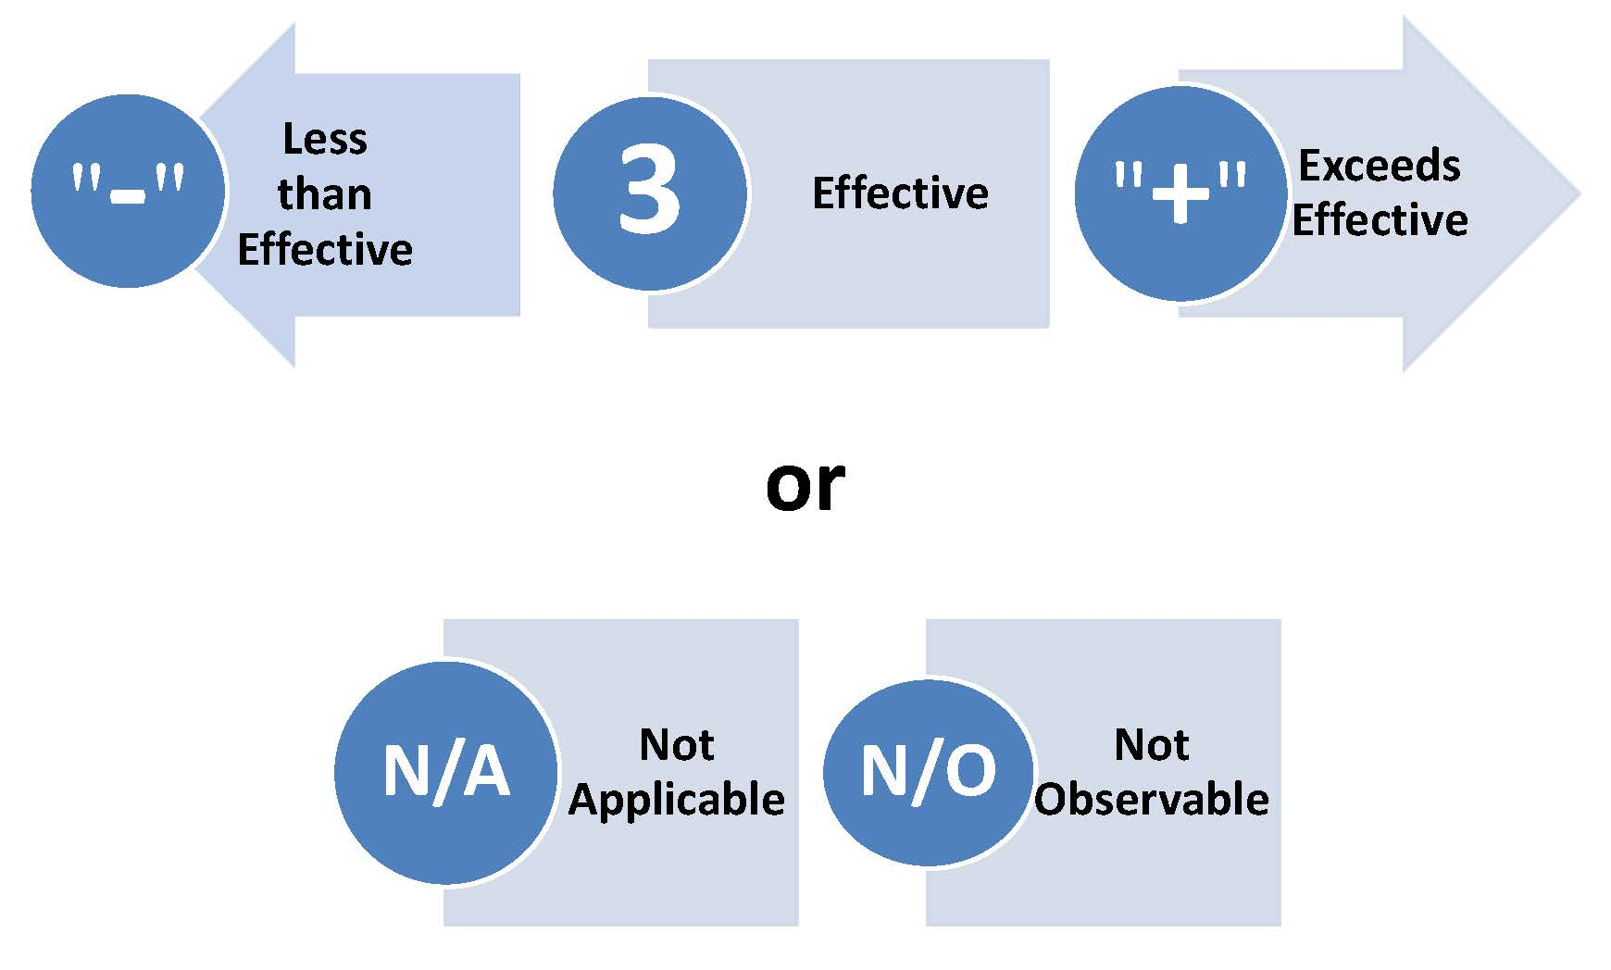  In addition to this coding or numeric rankings, the evaluators may write brief notes indicating strengths or areas of concern within the space below each indicator.  As noted above, the ratings and comments on the observation form should reflect the evaluator's total assessment of the teacher's performance from the date of the last observation or evaluation forward, whichever is later. Stated another way, the information on the observation form should describe evidence gathered from observations of the teacher’s classroom performance and other factors that quantify the impact of the educator, up to, and including, the date indicated on the observation form.
5.3  Important Housekeeping Measures regarding the Use of the Observation Form | - One observation form can be used for up to three observations, but will only pertain to an individual teacher.  - Be sure to write the name of the teacher whose observation is being documented on the bottom of the observation form.  - Before you begin your observation, indicate the date of the observation in the appropriate blank on the observation forms.  - Bring a copy of the rubric, as well as the observation form, to each observation to assist you in assessing the teacher's proficiency.
5.4  The Observation Conference:  A Requirement | Within five (5) days of each observation, the evaluator must conduct an observation conference with the teacher and provide him or her with a copy of the observation form. The observation conference should be a personal meeting between the evaluator and the teacher to discuss the evaluator's observations and coding on the observation form as well as the evaluator's comments and suggestions. The evaluator shall apprise the teacher of any issue, by specific domain, dimension and indicator that could lead to a less than effective rating on the evaluation form.
5.5  Copies and Signatures | - At the observation conference, ask the teacher to initial the appropriate blank on the observation form affirming the date and occurrence of the observation conference.  - Provide the teacher with a completed copy of the observation form, retaining a copy of the observation form for your records.
5.6  Teacher's Request for a Third Observation | Evaluators must conduct a third observation prior to the teacher's evaluation if a teacher requests an additional observation promptly after the second observation. As with other observations, the evaluator must conference with the teacher within five (5) days of completing the observation.
5.7  Teacher's Written Response to the Observation Forms | A teacher has the right to place in his or her file a response to the entries on the observation form within the timeframe established by state law for responding to evaluation documents. By written agreement or policy, district personnel may provide teachers with a longer window of time by which to submit their responses.
5.8  Observations and the Personal Development Plan | Evaluators may determine that a teacher's performance at an observation merits a personal development plan. A plan may be appropriate if the teacher's performance would have generated a ranking of 1-Ineffective or 2-Needs Improvement. The evaluator should use his or her professional judgment to determine whether an alternate approach to a PDP is preferable in light of the situation and context—for example, a brief conference, email or note may be a more appropriate and productive response than an automatic PDP for some lapses in performance. If the latter approach is used it is incumbent upon the evaluator to retain a documentation trail of the approach used, with timelines referenced.  - Important Note: If a PDP is written as a result of an observation, the evaluator must complete an additional observation (an observation in addition to the two standard observations) to confirm that progress is made on the targeted indicator.  See Section 7 for more guidance and requirements regarding personal development plans.

6. The Evaluation and Evaluation Conference

6.1  The Evaluation | Evaluators perform a teacher's evaluation by completing the evaluation form and conducting an evaluation conference. As noted throughout the handbook, an evaluation must be supported by two separate observations conducted in accordance with the relevant timeframes in addition to the evaluator’s appraisal over the course of the year of the teacher's proficiency in the relevant indicators. (See the note below regarding the limited circumstances in which a third evaluation is required.) The observation form summarizes those observations, including the total value that the teacher provides up to a given point in time.  Using the information from the observation form and any other pertinent data, the evaluator completes the evaluation form by issuing a rating for each observed and applicable performance indicator. The assigned ratings reflect the evaluator's analysis of the teacher's performance according to the descriptions in the rubric. The rubric and the evaluation form rely upon a five-level rating system, or spectrum of proficiency.

6.2  How to Determine an Indicator’s Score | Each indicator often has several definitional narratives for each level of proficiency. However, evaluators must enter only one (1) score as to each indicator (e.g., 1, 2, 3, 4, 5, N/O or N/A). To determine the composite score for each indicator, the evaluator must review the narratives contained within each indicator's definition and determine the "best fit" for the teacher with respect to that indicator, making a composite assessment of the “big picture” encompassing the indicator.  Example using the indicator for the domain of Instructional Effectiveness and dimension of Explains Content—Teacher teaches the objectives through a variety of methods:  The rubric defines a level “3-Effectiveness” ranking for this indicator with three (3) narratives. They include: uses cooperative learning activities, uses a variety of techniques, e.g., modeling, visuals, etc., provides differentiated tasks to meet learning styles, technology is included…  When the evaluator observes the teacher, she sees evidence of the teacher performing at a "3-Effectiveness" level in the majority of narrative definitions for the indicator. Specifically, the evaluator observes that the teacher is not using technology to support instructional planning and is not regularly using technology as an instructional tool. Though a 3 might not be a "perfect fit" for the teacher, the evaluator should still award a 3 for the indicator if a 3 is the "best fit." To address the fact that the teacher is not regularly using technology as an instructional tool, the evaluator would begin the “push-pin” process developing the expectation level for technology use within the classroom. (If that approach does not work, then there is no reason that a PDP could not be written on that targeted area even if the indicator resides at a level 3.)  There is no magic percentage of evidence within a proficiency level to trigger a particular rating for an indicator. For example, the evaluator did not need 80% of the narratives in evidence with regard to the 3-Effectiveness ranking to award a 3-Effectiveness ranking. The evaluator must use her professional judgment to determine the most appropriate ranking based upon the instructional significance of the individual narrative components and their impact upon student needs.

6.3  Not Applicable or Not Observed Indicators | If an evaluator believes that an indicator is not applicable to a particular teacher, he or she should rate the indicator as "N/A." Evaluators should rate not observed indicators as "N/O."  Note that indicator ratings of N/A and N/O do not “mathematically” magnify/increase the importance of the other indicators within the domain.
6.4  Indicators Receiving a Score of "1" or "2" | A rating of a 1 or 2 (Ineffective or Needs Improvement) on any indicator requires that evaluator provide the teacher with a personal development plan, which shall be attached to the evaluation form and reviewed during the evaluation conference. Personal development plans are covered in Section 7 of this handbook.
6.5  Indicators Receiving a Score of "4" or "5" | A rating of a 4 or 5 (Highly Effective or Superior) on any indicator requires that evaluator provide specific supporting comments within the evaluation form. If a teacher’s performance warrants a rating of 4 or 5 on more than one indicator within a domain, the comments may be clustered together on the Form.
6.6  Example comment for a rating of 5 (for a Teacher regarding Leadership) | Re Indicator 20/Leadership: "Ms. Smith extends herself via leadership and involvement well beyond expectations in a variety of venues. She has led the School Improvement Plan process during the past several years and now serves as the process manager for the WISE SI Plan conversion. She has a talent for writing interventions that serve as models across the curriculum and grade levels, and she has volunteered to make presentations to our school partners. She exemplifies the term "team player" and is a keystone to the success of the school. She also possesses an intuitive skill for mentoring others.”

6.7  Overall Scoring | As explained in Section 2, the teacher's overall score on the evaluation form is a weighted average of the domain's average ratings.
6.8  Evaluation Conference:  A Requirement | Like the observation conference described in Section 5, the evaluation conference is a vital tool in the TLE Observation and Evaluation System because it allows for critical feedback, reflection and discussions regarding the ways in which a teacher’s performance needs to improve and ways in which it is particularly strong. At the conference, the evaluator shall provide the teacher with a hardcopy of the signed evaluation form for the teacher to review and discuss with the evaluator. As noted above, if the teacher has received a less than effective ranking (a ranking of 1 or 2) on any indicator, the evaluator shall discuss those indicators with the teacher during the evaluation conference and transfer that discussion to a written and shared PDP.  At the conclusion of the conference, the teacher will sign the evaluation form. A completed copy of the same will be provided to the teacher for his or her records.
6.9  Teacher's Written Responses to Evaluations | A teacher has the right to place in his or her file a response to the entries on the evaluation form within the timeframe established by state law for responding to evaluation documents. By written agreement or policy, district personnel may provide teachers with a longer window of time by which to submit their responses.

6.10  Evaluation Frequency and Deadlines | Section 4 identifies the minimum number of evaluations that must be completed for each teacher and details the deadlines pertaining to evaluations. Evaluators may evaluate a teacher more than the statutory minimum as long as the evaluator adheres to the observation requirements and the relevant timeframes.
6.11  Teacher’s Artifact File or Portfolio | On a completely voluntary basis, a teacher may provide his or her evaluator with additional evidence of professional proficiency in the form of a portfolio or artifact file/binder for purposes of his or her evaluation. This is allowed; however, such evidence is not required. Moreover, an evaluator should be careful to not suggest that teachers produce a portfolio or artifact file, as they may feel as if it is an implied requirement or expectation of the evaluator. The portfolio and artifact file is simply a tool for expanding / prompting the thought processes of both evaluators and educators, since teachers regularly perform tasks, create documents, and take on responsibilities that are significant and valuable despite their commonplace nature.  A teacher may, for example, wish to create a binder with a tab or folder for each indicator into which he or she can “drop” a copy of the appropriate artifact as the year proceeds. (For example, if a teacher were to create a newsletter for his grade level or curricular area team, he could print an extra copy and insert it behind Indicator 20 – Leadership.) Before the evaluation, the teacher could share the binder or file of artifacts with his or her evaluator.  (see next page)  There are countless types of documents, plans and works that might be appropriate for a teacher’s portfolio or artifact file. In its Professional Growth System Handbook: 2008-2009, Montgomery County Public Schools included many of the following items as supplemental evidence of professional proficiency.
  • Assignments, projects, warm-ups  • Communication of standards, objectives and criteria for success on tasks  • Communications to students and parents  • Feedback on student work  • Grading policies and practices  • Records of data analysis and goal setting  • Appointments with students  • Student work samples and portfolios  • Unit or long-term lesson plans  • Annotated portfolio of support materials (beyond kit or textbook) for concept attainment or to convey mastery  • Informal assessments  • Assignments, project descriptions, etc.  • Documents distributed to students and parents, e.g., course syllabi, topic outlines, study guides, graphic organizers, etc.  • Material designed to teach thinking skills related to content concepts  • Room set-up  • Short-term lesson plans and materials  • Unit or long-term lesson plans and materials designed to support those plans  • Work displays  • Feedback on work and on student-set goals  • Grouping policies and practices  • Planning for technology incorporation  • Reflective conversations about responses to situations, overarching objectives, routines  • Room tours (e.g., what public messages are posted, what values are revealed)  • Records of communication to parents  • Student records of goal setting and self-analysis of work  • Student and parent survey data | • Assessment samples  • Grade books and similar artifacts  • Group and individual teacher reports on data analysis, findings and recommendations  • Logs minutes and records of grade-level, department and curriculum meetings  • Meeting notes with teacher on self-assessment and application to planning  • Videos of student portfolio conferences  • Collection of ideas, research, articles, etc. related to a WISE School Improvement Plan shared with colleagues  • Interview and conference data  • Log of professional development activities  • Professional articles or presentations  • Writings in learning logs, journals, school newsletters and reports  • Attendance records (work, meeting)  • Documentation of supporting school priorities outside the classroom  • Letters of thanks and commendations  • List of committee participation, presentations, etc.  • Logs, minutes, records of staff development or vertical team meetings  • Meeting agendas, minutes, notes  • Samples of student work, tests, assignments, feedback to students  • Long- and short-term lesson and unit plans  • Evidence of communication with parents  • Publications  • Professional development activities that contribute to improved practice  • Student achievement results and key indicators of student success  • Any available student and parent surveys

7. The Personal Development Plan

7.1  The Personal Development Plan | Personal development plans (PDPs) are intended to advise and assist teachers with serious performance deficiencies which, if left uncorrected, may jeopardize the teacher's continued employment with the district. Observations, evaluations or stand-alone incidents may trigger the issuance of a personal development plan. If developed in conjunction with an observation or evaluation, the personal development plan shall be attached to and considered another component of the observation or evaluation form.
7.2  When an Observation or Evaluation Requires a PDP | - A PDP may be issued, but is not required, in response to deficiencies noted during an observation. If issued, all PDP requirements within this section apply.  - Evaluators must develop a PDP for a teacher who receives a rating of 1-Ineffective or 2-Needs Improvement on any indicator in the evaluation form.  - Non-remediated PDPs from the observation process, which should result in a rating of 1-Ineffective or 2-Needs Improvement for the relevant indicator on the evaluation, are automatically incorporated into the evaluation and continue in effect without being redrafted or re-issued. The evaluator need only establish a new timeframe for compliance. Any new deficiencies resulting in an evaluation rating of 1-Ineffective of 2-Needs Improvement not covered by the non-remediated PDP must be supported by a newly issued PDP, however.
7.3  Designing and Issuing PDPs | Evaluators design and write the PDPs. They may collaborate with the teacher in the content of the PDP and seek assistance from outside sources as appropriate.  Before issuing a PDP to a teacher, evaluators must review the PDP with the teacher, most typically during the evaluation conference or observation conference. The teacher will receive an evaluator-signed hardcopy of the personal development plan and the teacher will sign the plan as acknowledgement of his or her receipt of the same.

7.4  PDP Content: SMART-Driven and Indicator-Specific | The PDP will state the specific goals or actions to be achieved by the teacher. The goals and required actions within the PDP should be "SMART”- formatted:  - Specific:  - identified with sufficient detail so that the "who, what and when" are clear, with regard to what the teacher must do and what resources/assistance are available to him or her.  - Measurable  - defined so that there is a starting point and final value to be achieved.  - Attainable  - defined by a final goal that is reachable within the given time frame assuming the reasonable efforts of the teacher and assistance of the evaluator.  - Resources  o identifies and provides resources that will assure increased effectiveness within the targeted performance areas.  - Time-Bound  - defined with an ultimate deadline and benchmarks reflecting the nature and gravity of the performance deficiency with timeframes to measure progress as appropriate.  - See the notes regarding limitations on timeframes below.  When the PDP is a result of the evaluation or an observation, the goals and actions must reflect and reference the relevant dimension and indicator. If there are concerns that do not clearly align themselves with a specific indicator, it may still be the target of a PDP and identified as a Stand-Alone PDP. In such cases, the PDP may be prefaced with the statement: "Although the following does not link directly with a performance indicator, there is a matter/situation/incident that falls within your area of responsibility/supervision that needs to be brought to your attention for action." Then, insert a summary of the matter/situation/ incident followed by a SMART goal plan of action.  Ms. Green - Personal Development Plan, 9/10/12  Re Indicator 14: Changes instruction based on results of monitoring.  Ms. Green will:  1) Observe Ms. Smith's class to gain insight on the various feedback strategies that can be employed.  2) Cite within Lesson Plans specific feedback strategies to be used.  3) Implement on a regular / routine basis three (3) feedback strategies; in evidence within 20 instructional days from the Teacher signature date.
7.5
Example PDP that is SMART-driven and Indicator-Specific

7.6  PDP Review and Follow Up Conference | The evaluator shall meet with the teacher to review his or her success in meeting the requirements and goals of the PDP in a follow-up progress review conference, which should occur in relation to the timeframes established in the PDP. This follow-up is a necessary component of all PDPs. Follow-up documentation must appear within the original PDP in the designated area of the PDP Form.
7.7  Teacher's Written Responses to PDPs | A teacher has the right to place in his or her file a response to the entries on the PDP form within the timeframe established by state law for responding to evaluation documents. By written agreement or policy, District personnel may provide teachers with a longer window of time by which to submit their responses.
7.8  Timeframes and Deadlines to Remember | - The timeframe for meeting the goals and actions in the PDP may not exceed two months.  - Remember that with regard to career teachers, the issuance of a PDP as a result of an observation shortens the timeframe for completing the evaluation. See Section 4.
7.9  Consequences of Non-remedied Deficiencies | The teacher must meet the PDP's requirements and goals in all respects by the specified deadline. Failure to do so may result in the teacher's dismissal or nonrenewal.
7.10  Stand-Alone PDPs | Evaluators may issue a PDP to a teacher as a stand-alone plan in response to a work-related incident or problem occurring outside the context of an observation or evaluation. In such cases, the evaluator's PDP will still follow the SMART Goals framework and the timeframes of the PDP described in this section.

8. Intensive Mentoring Supports (Optional)

8.1  Intensive Mentoring Supports | Districts are encouraged to explore mentoring supports for teachers needing intensive training. Specifically, at their discretion, districts may decide to offer customized mentoring supports to certain teachers receiving a PDP as a result of an observation or evaluation ranking of 1-Ineffective or 2-Needs Improvement. In such training programs, teachers are matched with a learning facilitator with their subject matter expertise. These learning facilitators are proven education specialists such as retired or former educators. They assist the selected teachers achieve the goals of their PDPs by using a targeted strategy for instructional improvement characterized by enriched and focused feedback. Learning facilitators help their assigned teachers and the relevant evaluators identify which skills and competencies need to be improved. Teachers participating in such a program would need to complete their training with the learning facilitator within two months. Participation in any intensive mentoring program would be voluntary, but those teachers who decline to participate in it when offered the opportunity should be asked to sign a document signifying their non-interest in the program.
8.2  Evaluators’ Role in the Intensive Mentoring Program | If a district decides to use an intensive mentoring program, evaluators should play a major role the development and implementation of the program and remain the official evaluator of the teacher. Evaluators are encouraged to continue informal observations, walk-throughs, conferences (such as to review lesson plans), professional development activities and other interactions with the teacher during any intensive mentoring program.
8.3  Relationship to Non-Renewals and Terminations | A teacher may be dismissed or non-renewed regardless of whether he or she has completed, participated in, or been offered a change to participate in any intensive mentoring program. Further, being in any such program shall not prevent a teacher from being placed on a personal development plan nor prevent the teacher from being recommended for dismissal or nonrenewal.

9. Tulsa Model Key Personnel

9.1  Key Personnel Supporting the  Tulsa Model’s  Observation and Evaluation System  and Processes | Tulsa Public Schools is committed to the successful rollout of its evaluation system across the state. TPS will support other districts in their implementation of and training in the Tulsa Model throughout the 2012-13 school year. A variety of communication and sharing platforms will be available to its partners.  Contact Information:  Tulsa Public Schools  3027 South New Haven  Tulsa, OK 74114  TheTulsaModel@tulsaschools.org  Office of Teacher and Leader Effectiveness (The Tulsa Model)  918-746-6800  Jana Burk – Director of TLE – burkja@tulsaschools.org  Katy Ackley - TPS Tulsa Model Fellow – ackleka@tulsaschools.org  Jennifer Gripado – TPS Tulsa Model Fellow – gripaje@tulsaschools.org  Gene Kleindienst – Lead Tulsa Model Trainer – kleinge@tulsaschools.org  Mark Modrcin – Project Specialist – modrcma@tulsaschools.org  Barbara Bottoms – Project Manager – bottoba@tulsaschools.org  Hannah Kang – Data Analyst – kangha@tulsaschools.org

Kathleen Cotton, Northwest Regional Educational Lab (2000). “The Schooling Practices that Matter Most.” ASCD. See also, Eric S., Tyler, John H., and Wooten, Amy L. (2011). “Identifying Effective Classroom Practices using Student Achievement Data,” The Journal of Human Resources, 46:3. See also Kane, Taylor, Tyler, and Wooten. (2010). “Identifying Effective Classroom Practices Using Student Achievement Data,” National Bureau of Economic Research Working Paper 15803. Kane, Taylor, Tyler, and Wooten. “Evaluating Teacher Effectiveness,” Education Next. www.educationnext.org/ evaluating-teacher-effectiveness. Summer 2010.

